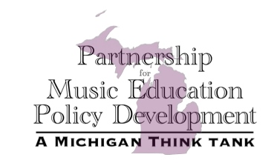
Partnership for Music Education Policy Development
Invites All Music Educators and Education Stakeholders to Attend
The 2014 Music Education Policy Summit
A meeting of educators and education policy makers to discuss education policy and the impact on music education.

June 14, 2014 – 9:30am-3:00pm
Michigan State University Cook Recital Hall

Scheduled to participate as Guest Speakers and on Q&A Panel Discussion:

Rebekah Warren, State Senator
Adam Zemke, State House of Representatives Appropriations Committee Member
John Austin, State Board of Education President
Eileen Weiser, State Board of Education Member
Dan Quinn, Executive Director of Great Lakes Education Research and Practice
Kathy Dewsbury-White, President/CEO of Michigan Assessment Consortium
Larry Hutchinson, Member of the Detroit Symphony Orchestra
Shawn Lewis-Lakin, Royal Oak Superintendent of Schools

This event is free, registration will take place
on-site starting at 9:00am, and lunch is on your own.

To learn more about PMEPD visit our web-site:
pmepd.weebly.com
or email us at: mich.pmepd@gmail.com

Partnership for Music Education Policy Development: A Michigan Think Tank
is a 501(c)3 non-profit organization

