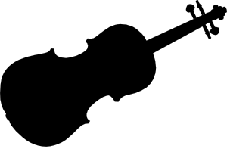
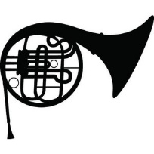
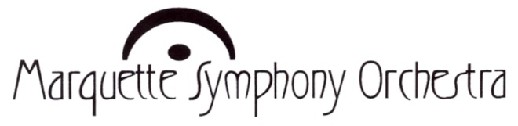

Young Artist
Concerto Competition

1st prize $1,000
and a featured performance with
The Marquette Symphony Orchestra in February, 2016

2nd prize $500 3rd prize $250

Competition Requirements:

1) No prior 1st place winners are allowed to participate.

2) Applicants must be 30 years of age or younger on January 1, 2016. Performers on any instrument will be accepted.

3) The 1st place winner will participate in community outreach in accordance with their schedule.

4) Send entrance form, a brief resume, video recording (with accompaniment) of a complete concerto, and a check or money order for a $35 application fee made payable to Marquette Symphony Orchestra by June 15, 2016 to the competition coordinator at the address below:

Barbara Rhyneer
Department of Music
Northern Michigan University
1401 Presque Isle
Marquette, MI 49855

NOTE: You may also email your materials and a link to your video recording to
brhyneer@nmu.edu and send the check separately as long as it is received by 6-15.

Winners will be notified by July 21, 2015. Please direct questions regarding your application to the competition coordinator: Dr. Barbara Rhyneer, brhyneer@nmu.edu, (906) 227-2309. Thank You.

Young Artist Concerto Competition
Entrance Form – 2015

Full Name: ________________________________________________
Current age: ____
Address: ____________________________________________________________ Street or PO Box City State Zip
Best contact phone number: _____________________________
Best email address: ________________________________________
Instrument: __________________
Name of Concerto: _____________________________________
Composer of Concerto: __________________________________
If you are 15 years of age or younger, please provide information below of a parent with whom we can also correspond, thank you:
(Parent or Guardian)
Name____________________________________________________
Email____________________________
Phone____________________________

Please submit the entrance form, resume, video recording (including accompaniment) of a complete concerto, and a check or money order for a $35 application fee made payable to Marquette Symphony Orchestra by June 15, 2015, to the competition coordinator:
Barbara Rhyneer, Department of Music, NMU, 1401 Presque Isle, Marquette, MI 49855
NOTE: You may also email your materials and a link to your video recording to brhyneer@nmu.edu and send the check separately as long as it is received by 6/15.

Winners will be notified by July 21, 2015. Please direct questions regarding your application to the competition coordinator: Dr. Barbara Rhyneer, brhyneer@nmu.edu, (906) 227-2309. Thank You.

