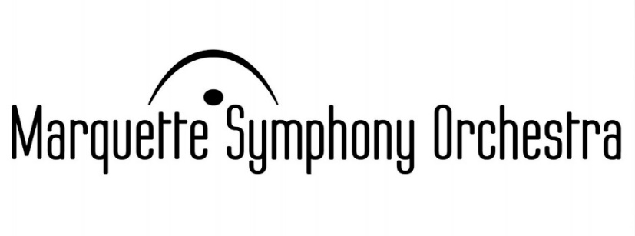
Young Artist
Concerto Competition
for
Strings & Piano



1st prize $1,000

and a featured performance with the
Marquette Symphony Orchestra in February 2018

2nd prize $500 3rd prize $250

Competition requirements:

- No prior 1st place winners are allowed to participate.

- Applicants must be string/piano players and 30 years old or younger on Jan. 1, 2018

- The 1st place winner will participate in community outreach as schedules permit.

- Send entrance form, a brief resume, video recording (with accompaniment) of a complete concerto and a check or money order for $35 application fee made payable to Marquette Symphony Orchestra by May 15, 2017 to MSO Concerto Competition, 501 S. Front St., Marquette, MI 49855 Videos may be submitted on line at: businessmanager@marquettesymphony.org Marquette Symphony reserves the right to use application videos for promotional purposes.

Winners will be notified by June 15, 2017. Please direct questions regarding your application to the competition coordinator: Janis Peterson, 906-250-4242, janispeterson@hotmail.com Thank you

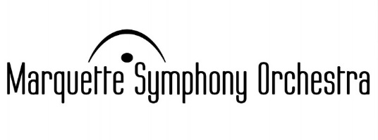
Young Artist
Concerto Competition
Entrance Form – 2017

Full Name: __________________________________________________________

Current Age: ______

Address: ____________________________________________________________________________
Street/PO Box City State Zip

Phone number: __________________________________________________

Email address: ___________________________________________________

Instrument: ___________________________________

Name of Concerto: __________________________________________________

Composer of Concerto: ________________________________________

If you are 15 years of age or younger, please provide information of a parent with whom we can also correspond:

Name of parent/guardian: ________________________________________________________

Email address: ____________________________________________________

Phone number: _______________________________________________

Please send entrance form, a brief resume, video recording (with accompaniment) of a complete concerto and a check or money order for $35 application fee made payable to Marquette Symphony Orchestra by May 15, 2017 to MSO Concerto Competition, 501 S. Front St., Marquette, MI 49855 Videos may be submitted on-line at: businessmanager@marquettesymphony.org Marquette Symphony reserves the right to use application videos for promotional purposes.

Winners will be notified by June 15, 2017. Please direct questions regarding your application to the competition coordinator: Janis Peterson, janispeterson@hotmail.com Thank you

