John Kendall Scholarships

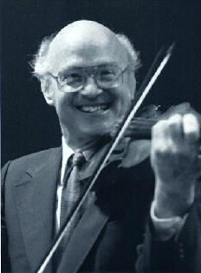

Teacher Scholarship:
$400 for Violin Unit 1 training at Blue Lake Suzuki Family Camp

Student Scholarship:
$250 for Violin Student attending Blue Lake Suzuki Family Camp

Deadline for application is April 20, 2017

For application information go to Blue Lake Suzuki Family Camp: https://bluelake.org/suzuki/

For further questions, contact Wendy Azrak at: wendy.e.azrak@gmail.com

Both scholarships are for Michigan residents only!

