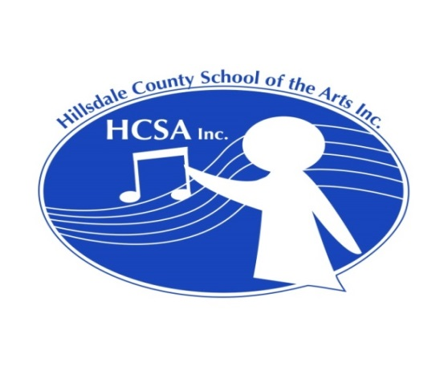

Needed: Violin instructor(s) in Hillsdale, Michigan

Permanent part-time position, beginning Sept. 2017

Approximately 3 days per week (could be divided between 2 teachers)

Approximately 20 students total to start; could add more students as you become established in the area

Also needed: Violin teacher to help with morning session of Hillsdale Summer String Festival

9:30 – 11:30 a.m., Monday – Friday, July 24 – Aug. 4, 2017 at Davis Middle School

Compensation is $20 per hour, plus help with transportation costs

For someone planning to teach in Hillsdale in the fall, this would be an excellent opportunity to become familiar with the students and with HCSA

Hillsdale County School of the Arts, Inc. (HCSA) was established in 2011 and gained 501(c)3 status in 2016. HCSA currently consists of a group of string and piano teachers who put on two recitals a year, in December and May. HCSA also sponsors the Hillsdale Summer String Festival, a summer program designed for elementary through high school string students. Elementary students meet Monday through Friday in the morning for two weeks. Middle and high school students meet in the afternoon during the second week of the festival. The seventh annual String Festival will feature guest artists Gene Hahn, violin, and Jeremy Crosmer, cello, of ESME (Eclectic String Music Ensemble.) For more information about HCSA and the String Festival, visit our website at www.HillsdaleCountySOTA.com.

Judy Bixler, founder and director of HCSA and the Summer String Festival, has been teaching violin (and occasionally viola) in Hillsdale for 18 years. She and her husband will be moving from the area in the fall. Cellist David Peshlakai will assume the duties of director of HCSA and the String Festival, but Judy needs someone to take over her students. Her students range from 2nd grade through 11th grade, with around 7 in elementary school, 13 in middle school and 5 in high school. Her least advanced student is currently a Twinkle beginner and most advanced student is at the level of volumes 3 - 4 of the Barber "Solos for Young Violinists," although she has had slightly more advanced students in the past. She uses the Suzuki books, particularly books 1 - 4, but does a LOT of supplementing. She occasionally has students who don't relate well to the Suzuki pieces, and in those cases she focuses entirely on supplemental materials.

Another teacher with HCSA will be able to take a few additional students in the fall, so someone is needed to cover two to three days of teaching. It may be difficult to find one person who can do that, so it would be fine to divide the students between two teachers. Recently, the bulk of Judy’s teaching has been Wednesday through Friday. She does most of her teaching at home and doesn’t always schedule students back to back. If consolidated, her schedule for those three days would look something like this:

Wednesday -- 7 students from 3:30 to 8 p.m. with an hour dinner break from 6 to 7.
Thursday -- 9 students from 1:00 to 5:30 p.m.
Friday -- 5 students from 2:00 to 5:45 p.m. (2:00 student has lessons at school during a study hall. This results in some unavoidable downtime before starting after-school students.)

Weekend lessons are not recommended because of sports conflicts, but otherwise lesson days and times are at the discretion of teacher and student. The current fee is $20 per half hour lesson. An incoming teacher should plan to start at that rate and move up incrementally from there. HCSA does not have its own quarters, but an out-of-town teacher will be able to use space at a local church free of charge.

If interested, please contact Judy Bixler at bixlersmith@sbcglobal.net.

