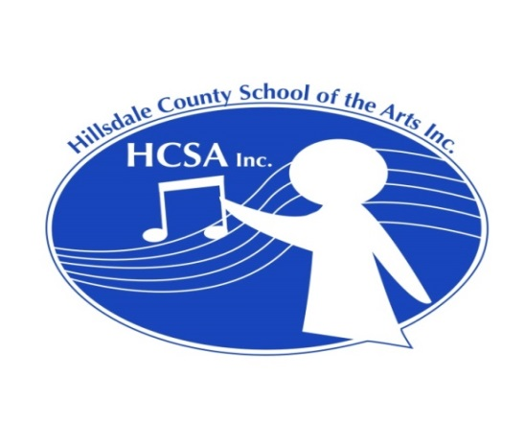

Needed: Violin instructor in Hillsdale, Michigan

Permanent part-time position, beginning Sept. 2017

Currently need someone to teach in Hillsdale one day per week

Up to 8 students

Hillsdale County School of the Arts, Inc. (HCSA) was established in 2011 and gained 501(c)3 status in 2016. HCSA currently consists of a group of string and piano teachers who put on two recitals a year, in December and May. HCSA also sponsors the Hillsdale Summer String Festival, a summer program designed for elementary through high school string students. The seventh annual String Festival will feature guest artists Gene Hahn, violin, and Jeremy Crosmer, cello, of ESME (Eclectic String Music Ensemble.) For more information about HCSA and the String Festival, visit our website at www.HillsdaleCountySOTA.com.

Judy Bixler, founder and director of HCSA and the Summer String Festival, has been teaching violin (and occasionally viola) in Hillsdale for 18 years. She and her husband will be moving from the area in the fall. Cellist David Peshlakai will assume the duties of director of HCSA and the String Festival, but Judy needs someone to take over her students. Her students range from 1st grade through 11th grade, with around 7 in elementary school, 13 in middle school and 5 in high school. Her least advanced student is currently a Twinkle beginner and most advanced student is at the level of volumes 3 - 4 of the Barber "Solos for Young Violinists," although she has had slightly more advanced students in the past. She uses the Suzuki books, particularly books 1 - 4, but does a LOT of supplementing. She occasionally has students who don't relate well to the Suzuki pieces, and in those cases she focuses entirely on supplemental materials.

Several local teachers are able to take additional students in the fall, so someone is needed to cover one day of teaching.
The number of students will depend upon the teacher’s and students’ schedules, but could easily be as many as eight after-school lessons in one day. Weekend lessons are not recommended because of sports conflicts, but otherwise lesson days and times are at the discretion of teacher and student. The current fee is $20 per half hour lesson. An incoming teacher should plan to start at that rate and move up incrementally from there. HCSA does not have its own quarters, but an out-of-town teacher will be able to use space at a local church free of charge.

If interested, please contact Judy Bixler at bixlersmith@sbcglobal.net.

