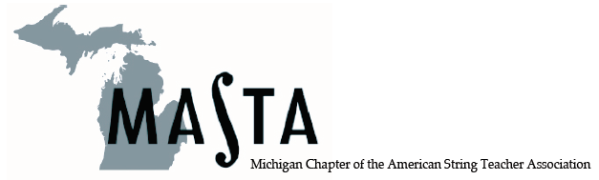

Invitation

What: Reception – Appetizers, Awards,
Traverse City Wines, Fellowship

Who: MASTA members with guest

Where: Amway Grand – Van Andel Suite #2690

When: January 26, 2018, 8:30 – 11 pm
after the Teacher Orchestra Concert

Why: It’s FREE and FUN!

