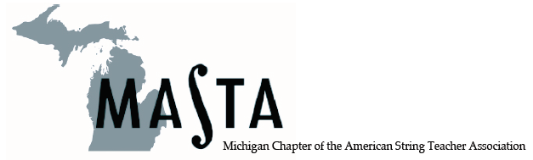

Invitation

What: Reception – Pizza, Soda,
Freebies, Meet the MASTA Board

Who: New String Teachers and
MASTA student chapter members

Where: Amway Grand – Van Andel Suite #2690

When: January 25, 2018, 9 – 11 pm
after the MMC Opening Concert

Why: It’s FREE and FUN!

