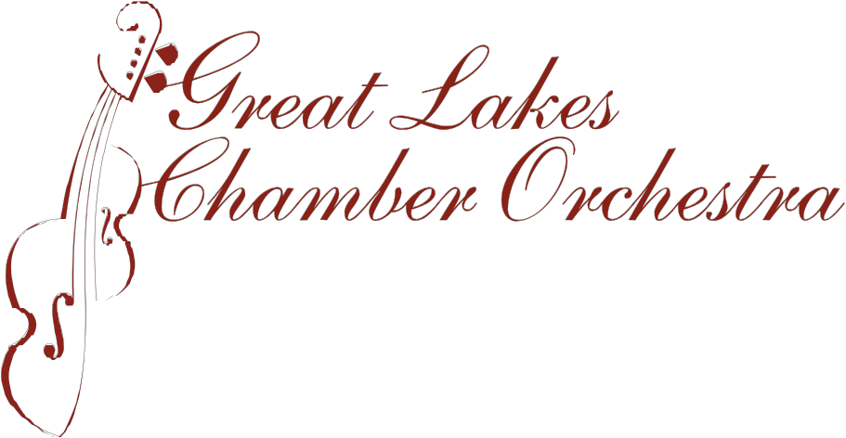
.
438 E. Lake Street • Petoskey, MI 49770 • 231-487-0010 • w w w. glcorchestra.org

Great Lakes Chamber Orchestra—Emerging Artist Competition
The Great lakes Chamber Orchestra announces the annual Charles F. Davis Emerging Artist Competition. The competition is available to students of piano, winds, brass, percussion, strings and voice between the ages of fourteen and nineteen, residing in Northern Michigan between the 45th Parallel and the Straits of Mackinac. The Concerto Competition will be held at the Petoskey United Methodist Church on April 22, 2018. At 1:00 p.m.
Application forms are available from instrumental and vocal teachers in the area and GLCO Office at 231 487 0010 or online at www.glcorchestra.org. Students are encouraged to speak with their teachers or to contact GLCO for additional information
Deadline for entry: Contestants must submit a completed application form, along with a $15.00 non-refundable application fee made payable to the Great lakes Chamber Orchestra. Applications must reach the Great Lakes Chamber Orchestra office, 438 Lake Street, Petoskey, 49770 by 5:00 PM on Tuesday, April 3, 2018.
Requirements:
1. Work(s) to be performed: instrumentalists: a single movement for which an orchestral arrangement is available. Vocalists: two compositions in two foreign languages—one of which must have an orchestral arrangement.
2. Each contestant is to provide an accompanist, when necessary, at the contestant’s expense.
3. Three copies of the piece(s) performed must be supplied for the judges. Photocopies are acceptable. All copies will be returned to the performers.
4. Total playing time should be no less than 5 minutes and no more than 10 minutes
5. Performance is to be done by memory.
Grand Prize Winner ($500) may be invited to perform with the GLCO.
First runner-up ($250) may be invited to perform at a GLCO Ensemble Concert.
Contestants will be notified of their individual audition times within a week following the deadline date. Audition times will be randomly selected and may be negotiated. A warm-up room will be provided prior to the audition time. The competition will be held before a live audience.
For additional information, please contact Maggie Poxson at 231-881-8196 or the office of Great Lakes Chamber Orchestra 231-487-0010

