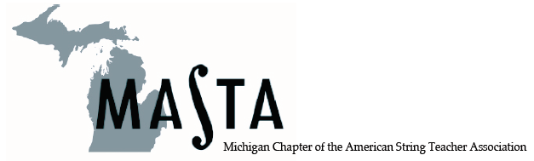
Studio Teacher Workshop
Monday, August 6, 2018 9 AM – 3:30 PM
Central Michigan Univ,. 162,Mt. Pleasant, MI 48858
Multi-level Master Classes by:
David Reimer, Violin
Renee Skerik, Viola
Andrea Yun, Cello
Larry Hutchinson, Bass
Classes on the business of private teaching, practice tips, conquering performance anxiety, bass for the non-bass teacher, a presentation by CMU music faculty and more!
Lunch included! SCECH’s available for $15
Registration Fee: MASTA members $25
Non-members $75
E-mail janispeterson@hotmail.com to register.
Please respond before June 1st

